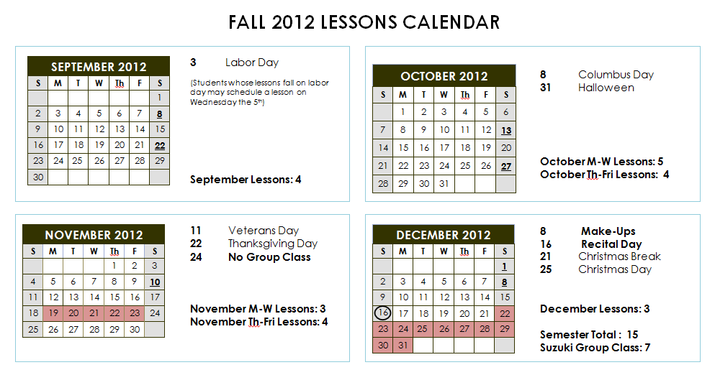

Key_____________________
02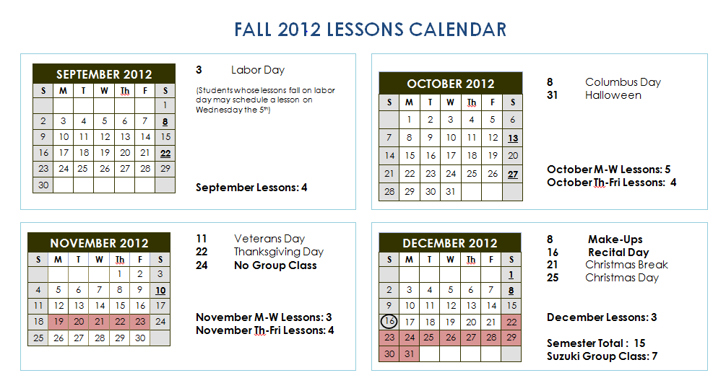
= Suzuki Group Class

= Holiday/No Lessons
02
= Recital Day

September:

3 Labor Day (students may reschedule for Wed the 5th)
8, 22 Suzuki Group Class (9-10 am)

October:

13, 27 Suzuki Group Class

November:

10 Suzuki Group Class
19-23 Thanksgiving Week- No Lessons

December:

1, 8 Suzuki Group Class
8 Semester Make-up Day
16 Recital Day
21 End of Fall Semester

(Note: There will be lessons the week after the recital)

End of Semester Make-ups:

Students may receive one make-up lesson per semester on the end of semester make-up day. For students who cancel more than one lesson per semester, additional make-ups are not guaranteed.

Fall Recital:

The fall 2012 semester recital is scheduled for Sunday, December 16th at 4pm, at Blackerby Violin Shop on Anderson Lane.

Blackerby Violin Shop
1111 West Anderson Lane,
Austin, TX 78757

Please arrive between 3:30 – 3:45 so that we have time to tune, get settled, and set up any recording devices. The recital will start promptly at 4pm.

Recital Etiquette: Absolutely no picture taking before or during a performance, as this can be distracting to the performer. You may however set up a recording device at the beginning of the recital, or take non-flash photos during applause. Also we will organize a post-recital group photo.

A recital fee will be assessed two weeks prior to the recital to cover rental of the space and accompanist fees. The recital fee is normally within the range of $25- $35.

